**Amazon AWS Route 53 GEO DNS Configurations**

ou can send visitors to different servers based on country of their IP address using Amazon Route 53 cloud based dns server. For example, if you have a server in Amsterdam, a server in America, and a server in Singapore, then you can easily route traffic for visitors in Europe to the Amsterdam server, people in Asia go to the Singapore server and those in the rest of the world be served by the American server. This will results into the various kinds of benefits such as:

**Better performance** as you are sending web site visitors to their nearest web server.

**Reduced load** on origin.

**Geomarketing** /online advertising.

**Restricting content** to those geolocated in specific countries (I am not a big fan of DRM).

In some cases you can get potentially **lower costs** and more.

In this post, I will explain how to configure and test GeoDNS using AWS Route 53 service.   
**Our sample setup**

[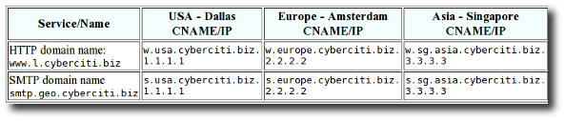](https://www.cyberciti.biz/topics/cloud-computing/aws/)

*Fig.01: Sample geodns setup for HTTP/SMTP service*

Please note that IPs (1.1.1.1) or CNAMEs (w.usa.cyberciti.biz) can be hosted by AWS or your own server anywhere in the world.

**AWS Route 53 routing policy**

From the Route 53 documents:

If your application is hosted on Amazon EC2 instances in multiple EC2 regions, you can reduce latency for your end users by serving their requests from the EC2 region for which network latency is lowest. Route 53 latency-based routing lets you use DNS to route end-user requests to the EC2 region that will give your users the fastest response.

It is possible to use Route 53’s Latency Based Routing (LBR) feature with non-AWS endpoints or IP address. Route 53 don’t restrict what IPs or CNAMEs you can tag with a region. AWS dns server will route traffic to those IPs/CNAMEs “as if” those IPs or CNAMEs were hosted in whichever AWS region you choose to tag. The following is the current list of regions supported by Route 53 LBR:

Nothern Virginia, US: us-east-1

Nothern California, US: us-west-1

Oregon, US: us-west-2

Ireland, EU: eu-west-1

Singapore, Asia: ap-southeast-1

Tokyo, Asia: ap-northeast-1

Sydney, Asia: ap-southeast-2

Sao Paulo, South America: sa-east-1

**Configuration**

First, open the Amazon Route 53 console at <https://console.aws.amazon.com/route53/>> Choose your existing domain > Click on the **Go to Record Sets** button > Click on the **Create Record Set** button.

**CNAME geodns settings for USA Dallas server**

Set **Name** to www.l .

Choose **Type** to CNAME .

Set **TTL** to 30 seconds.

Set **Value** to w.usa.cyberciti.biz. seconds.

Set **Routing Policy** to Latency .

Set **Region** to us-west-1 .

Set **ID** to Dallas, TX, Data Center .

Click the **Create Record set** button to save the changes.

[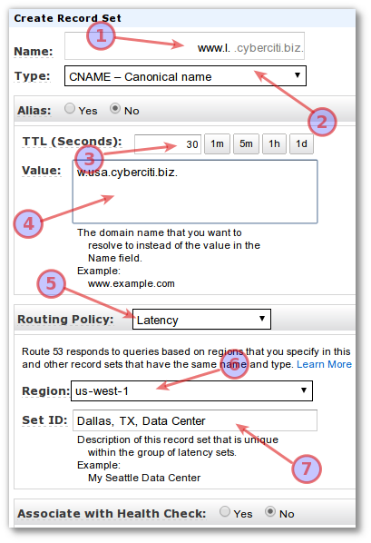](https://s0.cyberciti.org/images/faq/2013/04/aws.route53.geodns.1.png)

*Fig.02: CNAME geodns settings for Dallas/USA server.*

**Set an IP address for CNAME w.usa.cyberciti.biz**

Visit the Amazon Route 53 console at <https://console.aws.amazon.com/route53/>> Choose your existing domain > Click on the **Go to Record Sets** button > Click on the **Create Record Set** button.

Set **Name** to w.usa .

Set **Type** to A - IPv4 address .

Set **TTL** to 30 seconds.

Set **Value** to 1.1.1.1 . Please replace IP address 1.1.1.1 with your actual AWS endpoint or any other valid public IP address in US.

Set **Routing Policy** to Simple .

Click the **Create Record set** button to save the changes.

[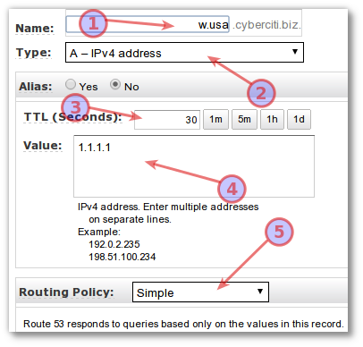](https://s0.cyberciti.org/images/faq/2013/04/aws.route53.geodns.cname-ip.png)

*Fig.03: Set an IP address for CNAME w.usa.cyberciti.biz.*

**Repeat this process** for the rest of your HTTP and SMTP services. At the end, your setup should look like as follows:

[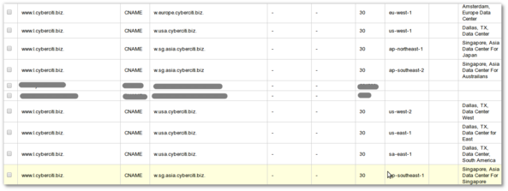](https://s0.cyberciti.org/images/faq/2013/04/aws.cname.large.png)

*Fig.04: Showing all CNAME and AWS geo mapping for each region (click to enlarge).*

[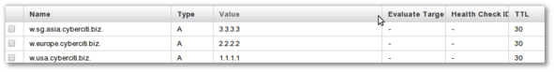](https://s0.cyberciti.org/images/faq/2013/04/aws.cnames-to-ip.png)

*Fig.05: IP address for all CNAMEs.*

**Test it**

Use the following [dig or host dns lookup command line utilities](https://www.cyberciti.biz/faq/unix-linux-dns-lookup-command/) to verify new settings:

% dig +short www.l.cyberciti.biz.

Sample outputs from various locations:

|  |
| --- |
| *## Asia ##* w.sg.asia.cyberciti.biz. 3.3.3.3 *## Office in UK ##* w.europe.cyberciti.biz. 2.2.2.2 *## IDC in US ##* w.usa.cyberciti.biz. 1.1.1.1 |

The following images shows the accuracy of geo name-to-IP address resolutions around the world for www.l.cyberciti.biz:

[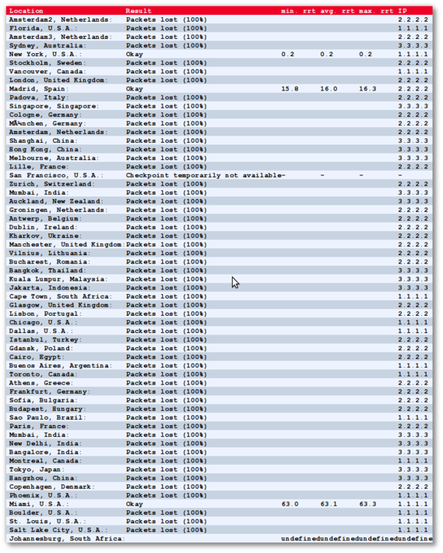](http://just-ping.com/index.php?vh=www.l.cyberciti.biz&c=&s=ping%21)

*Fig.06: Route 53 geo location accuracy*